Calculus I Name
Intro to Limits Block Date

Given determine the following.
- f(1) = 2) f(0) =

To find out what is happening to the graph of a function when we cannot evaluate it at a certain value we use a .

Instead of asking what does f(x) equal when x is a certain value,
we ask what does f(x) approach as x approaches a certain value.

Limit Notation

One Sided Limits

Left Hand Side: Right Hand Side:

For a limit to exist:

Example 2:

First, find the left & right hand side limits… if they are equal then the limit exists & is the value you got for each.

You can also find limits by looking at the graph of a function.
Given the graph of f(x), find the following limits if they exist.
a)
b)
c)
d)
e)
f)
g)
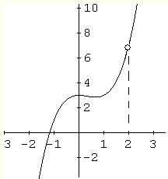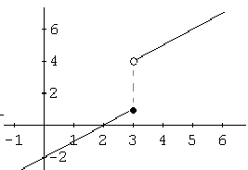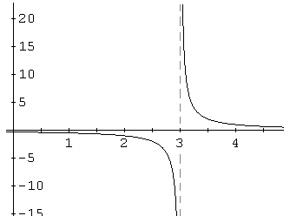

g(3) = h(3) =

If a graph is continuous you can simply plug in the value to find the limit.
1) 2) 3)
4) 5) = 6)
The indeterminate form:
When direct substitution gives you , simplify the function algebraically and substitution again.
Algebraic methods for finding limits:
1. Direct substitution
2. Simplify expressions
7) $\underset{x→−3}{\text{lim}}\frac{x^{2}−9}{x+3}$ = 8) $\underset{x→1}{\text{lim}}\frac{x^{2}+x−2}{x^{2}−1}$ = 9) $\underset{x→4}{\text{lim}}\frac{x^{2}−7x+\text{12}}{x^{2}+8x−\text{48}}$=

Homework Problems: Find the value of the requested limits. Use algebra (if possible) or the graphing calculator. If you use the calculator, write “calc” next to your answer.
1) 2) 3)

4) 5) 6)

7) 8) 9)

